NHB+ Reading Offers

What’s Working Now

- When it comes making anything convert better
- To the degree that they can visualize, see and understand and COMPREHEND will determine how easily they are motivated in order to buy.
  - Comprehension
  - Comprehensive
  - Means = everything, totality, whole, etc…
- They need to be able to understand how things relate to teach other contextual in their world
- Translate and do the math for them
- We have the 5 senses, and all our communication online is done through TWO of them
- Eyes and ears
- We’re a little bit limited in terms of how we can communicate with them because all of the data is going through only two senses
- And out of these two senses we have to construct a reality in their minds
- This construction of reality in their minds requires a lot of work
- Who’s going to expand the energy doing it?
  - They don’t want to, unless there is something in it for them
  - So that means we SHOULD
- Tell them something, then tell them what it means, and how it impacts or helps them
- Show them something, then tell them what you just showed them and how it impacts and helps them
  - And the way you do that is you just say “And that’s why…”
  - Or “And now you can see how”
  - Or “And now you know when _____ happens, you need to ______”
- Do the math for them
  - If you have any type of biz op, you always have to the math for them, because they’re not going to do it themselves
- The rule of thumb is, any energy expansion will be declined and will limit the offer conversion
- The more energy they have to expend the less the offer will convert
- Any offer where you have sequential attrition they’ll have expand energy and leave
- Do the math, but don’t CONCLUDE the math
- When you conclude the math in an offer, you are making direct claims
- So one of my favorite lines is:
  - We’ll show you how to make it, how much you make is up to you.
- Only for 30 people ❌
- Next 30 people ✅
- Translate but don’t conclude the MEANING, let them form the meaning
- Bentely and RR will never say “you have status if you have one”, they’ll lead you to make that conclusion
- So marketing mastery at the highest level is the ability to lead people to their limitations, through their limitations and to their own conclusion.
  - If I conclude something and say it’s true, then I will fight you for that truth, because it’s MY truth
  - Vs if you accept someone's truth, then how different is that from accepting someone else's truth?
  - If you get someone to say “this is my truth” their behavior and ACTION has to validate that, so the only rational thing is for them to buy your stuff, otherwise it can’t be true.
- How do we translate better
- Put pictures of happy people in social situations on the page
  - That mirror what you’re talking about
- Whenever we see other people wanting something, and participating in something, the more we desire it

Fitness offers for men

Fitness for men and sales are two of the toughest markets right now

Because one is overly saturated the other sells to people all day so hard to overcome their objections

Show THEN tell not Tell then SHOW

Show them the results, then tell them (translate)
Show them the scene, then tell them (translate)

When it comes to hyper aware and saturated markets, the way to cut through is to SHOW then tell.

This is why you see some dumbshit on IG who’s ripped, who’s never heard of copy, hooks or anything make a whole lot of money.

If we assume that all markets are leading to maturation and hyper awareness, then it would be smart of us to SHOW then tell.

We show them the math, we do the math and then let them conclude their own math.

So infomercials and QVC all have one thing in common, show, then tell.

When you show something, you FORCE the attention on that something.

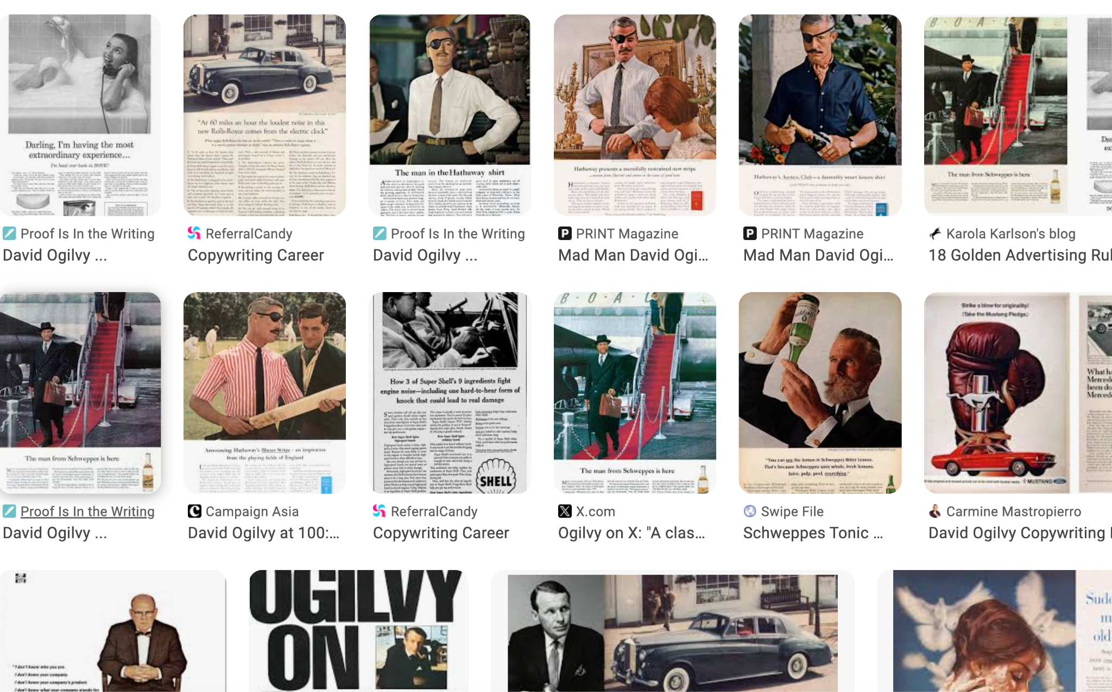

If you look at all of the BEST ads in history from David O and others, they are all SHOW and then TELL.

This is a much better way of communicating because the EYE will generalize 1st then goto specific.

So anyone can say stuff, but not everyone can show.

If I ask you, if I show you something or tell you something, what would you believe?

If I have to TELL you vs show you, I have to expand 20-50x amt of energy to convince vs you seeing it.

Reading Offers

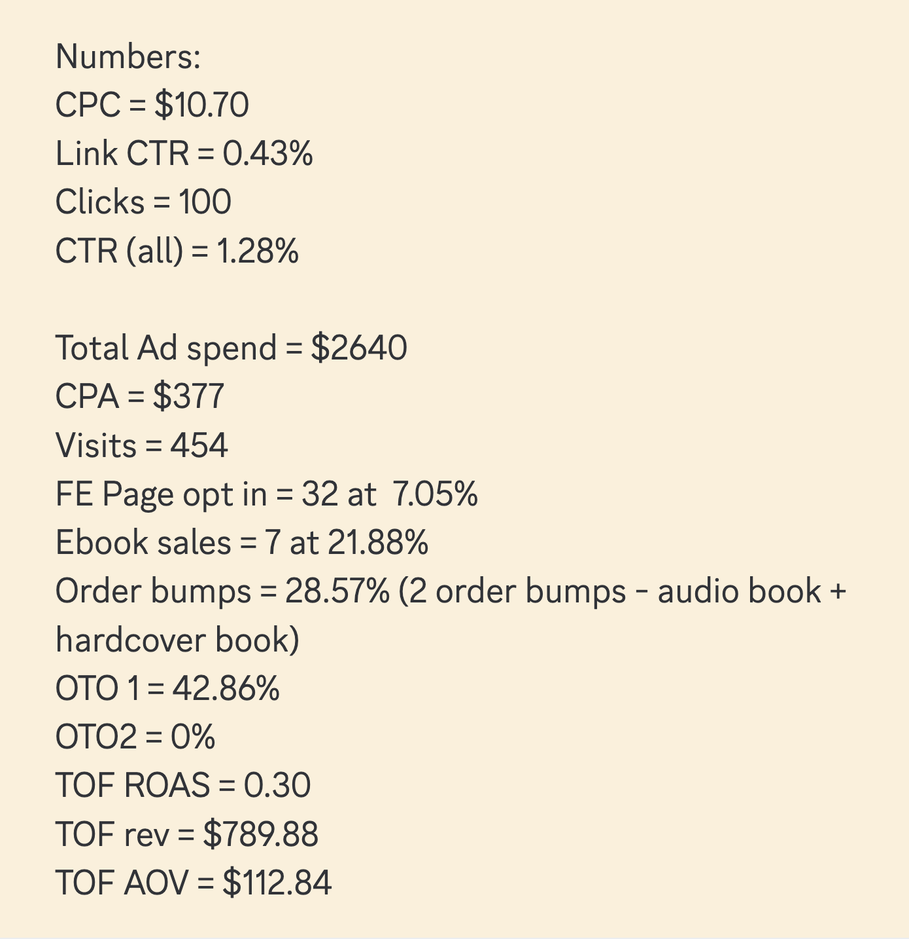

Time, energy and money = all are one

It flows where there is least resistance

Can the energy FLOW through it or do I have to spend energy on it to force it to flow thru

Any spending is done to overcome resistance.

So spending money, time or energy.

